# **Department of Computer Science and Engineering Islamic University of Technology (IUT)** A subsidiary organ of OIC

# **Laboratory Report**

# CSE 4502 : Operating System Lab

|  |  |
| --- | --- |
| **Name** | **: Maheen Mashrur Hoque** |
| **Student ID** | **: 190042148** |
| **Section** | **: SWE** |
| **Semester** | **: 5th** |
| **Academic Year** | **: 2022** |
| **Date** | **: 14/08/2022** |
| **Lab No** | **: 1** |

### **Title:** Understanding the basic commands of Linux systems.

#### Theory:

Linux systems started as a CLI (Command Line Interface) system for the users to use the operating system. The CLI provides a plethora of commands for the users to perform various basics to advanced tasks.

#### Commands:

i. Basic commands:

1. pwd  
   “pwd” command shows the current directory the user is in.   
   
2. ls (with –a flag)  
   “ls” shows all the files and subdirectories in a directory (if directory name is not specified, it will show the contents of the current directory). The –a flag also shows the hidden files and directories.  
   
3. cd  
   “cd” changes the current directory to the one specified.   
   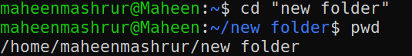
4. mkdir and rmdir  
   “mkdir” creates a specified directory and “rmdir” removes a specified directory.  
   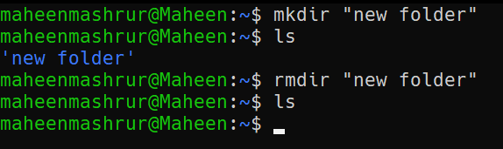
5. touch and rm  
   “touch” creates a specified file and “rm” deletes a specified file.  
   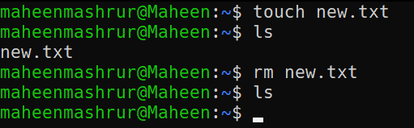
6. man and –help (for touch command)  
   “man” shows the manual of a command (manual contains detailed information about that command). “--help” shows the flags and usage of a command. Both are used with another command. Here, both are shown for the command “touch”.  
     
   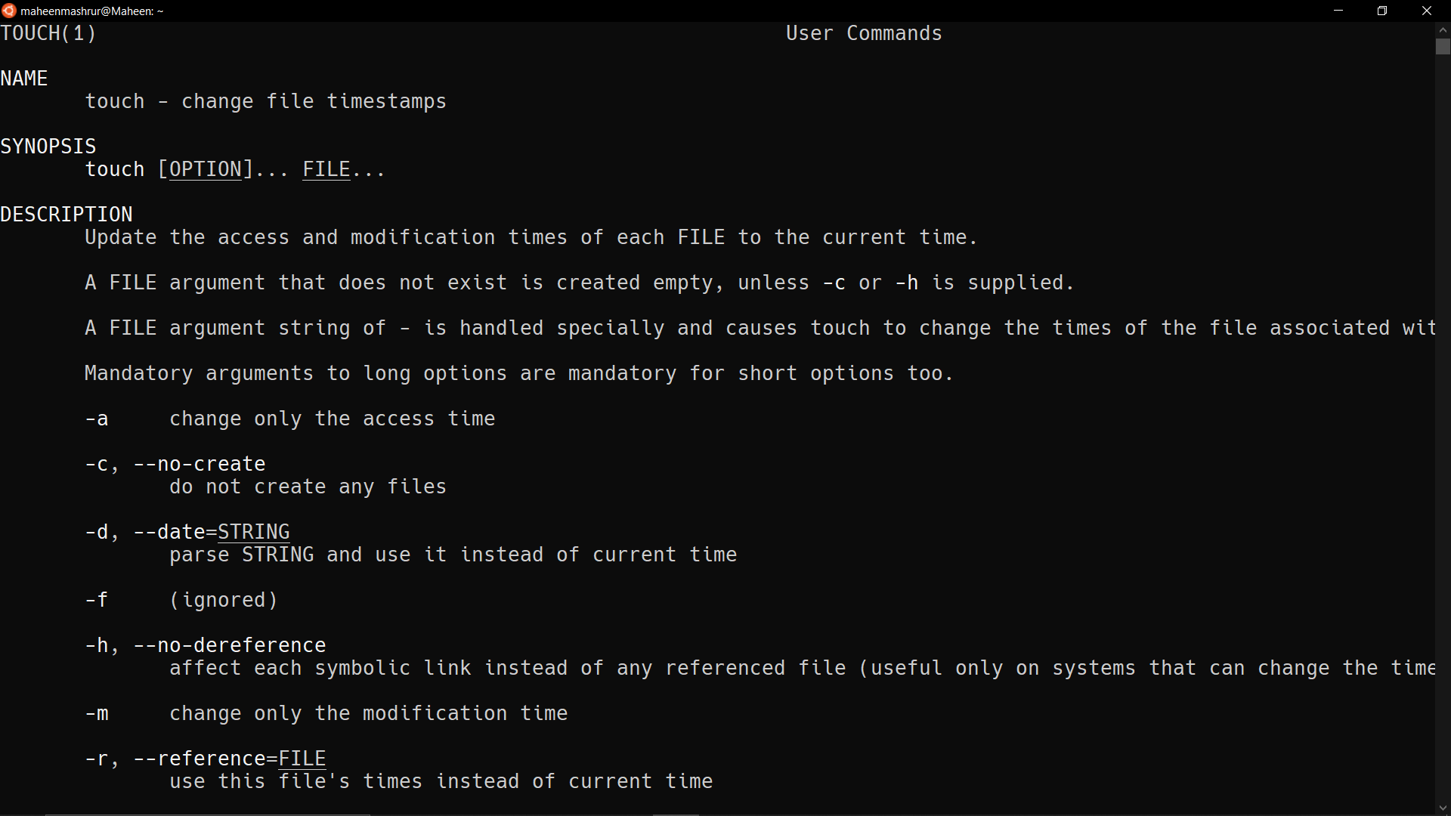  
   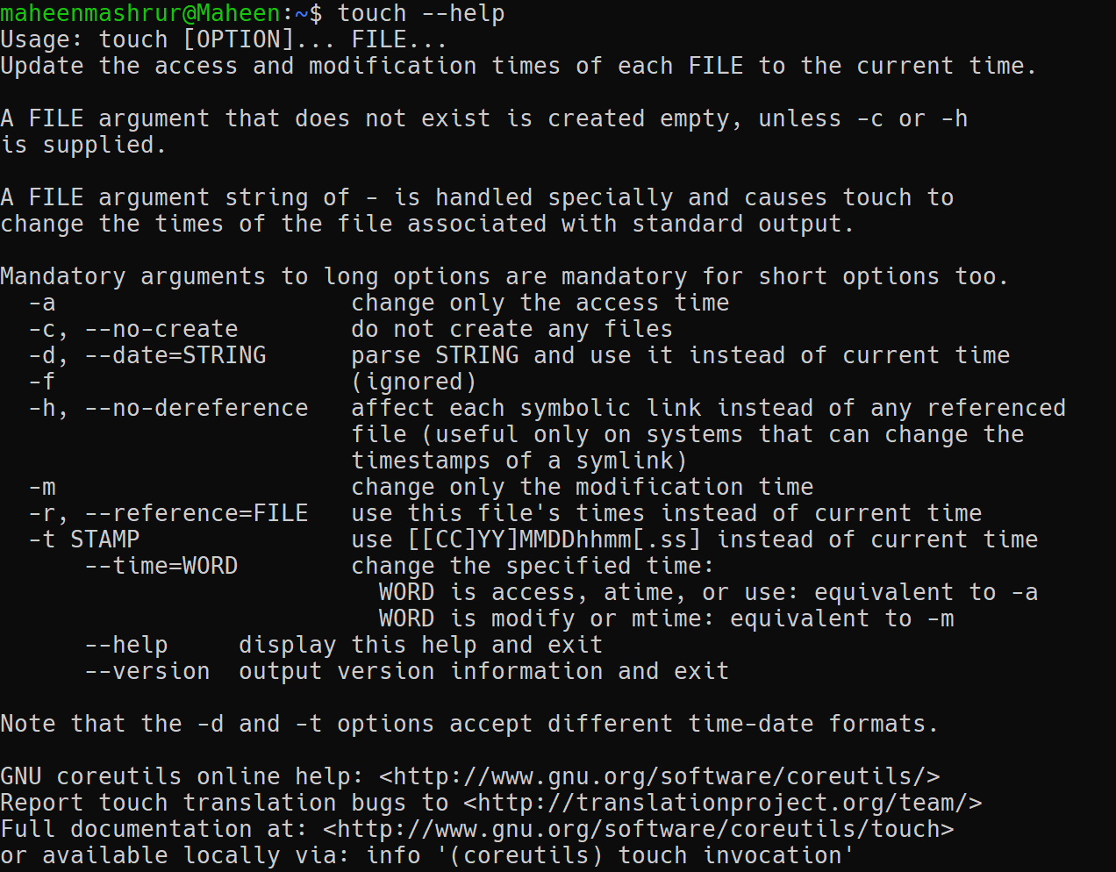
7. cp command  
   “cp” copies a file or directory into another specified directory.  
   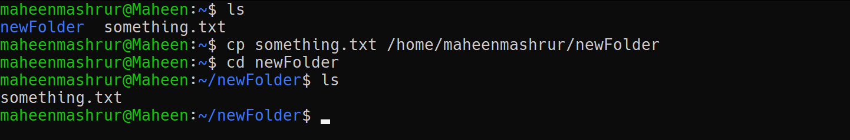
8. mv command  
   “mv” moves a file or directory into another specified directory.  
   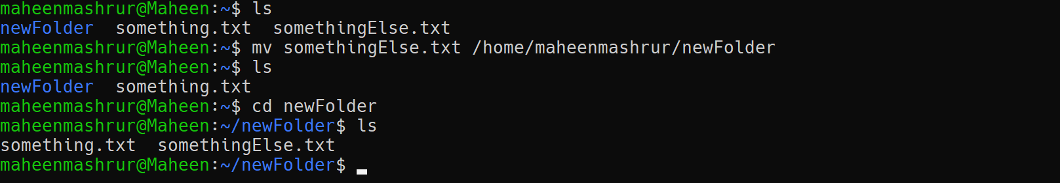

ii. Intermediate commands:

1. echo and cat command  
   “echo” is used to move data to a specified file. It can also be used to print something in the CLI.  
     
   
2. vi command  
   “vi” is used to open a built in text editor named Vim. We can also specify the file to edit (as shown in the screenshot). Vim has it’s own commands for editing and various other utilities.  
     
   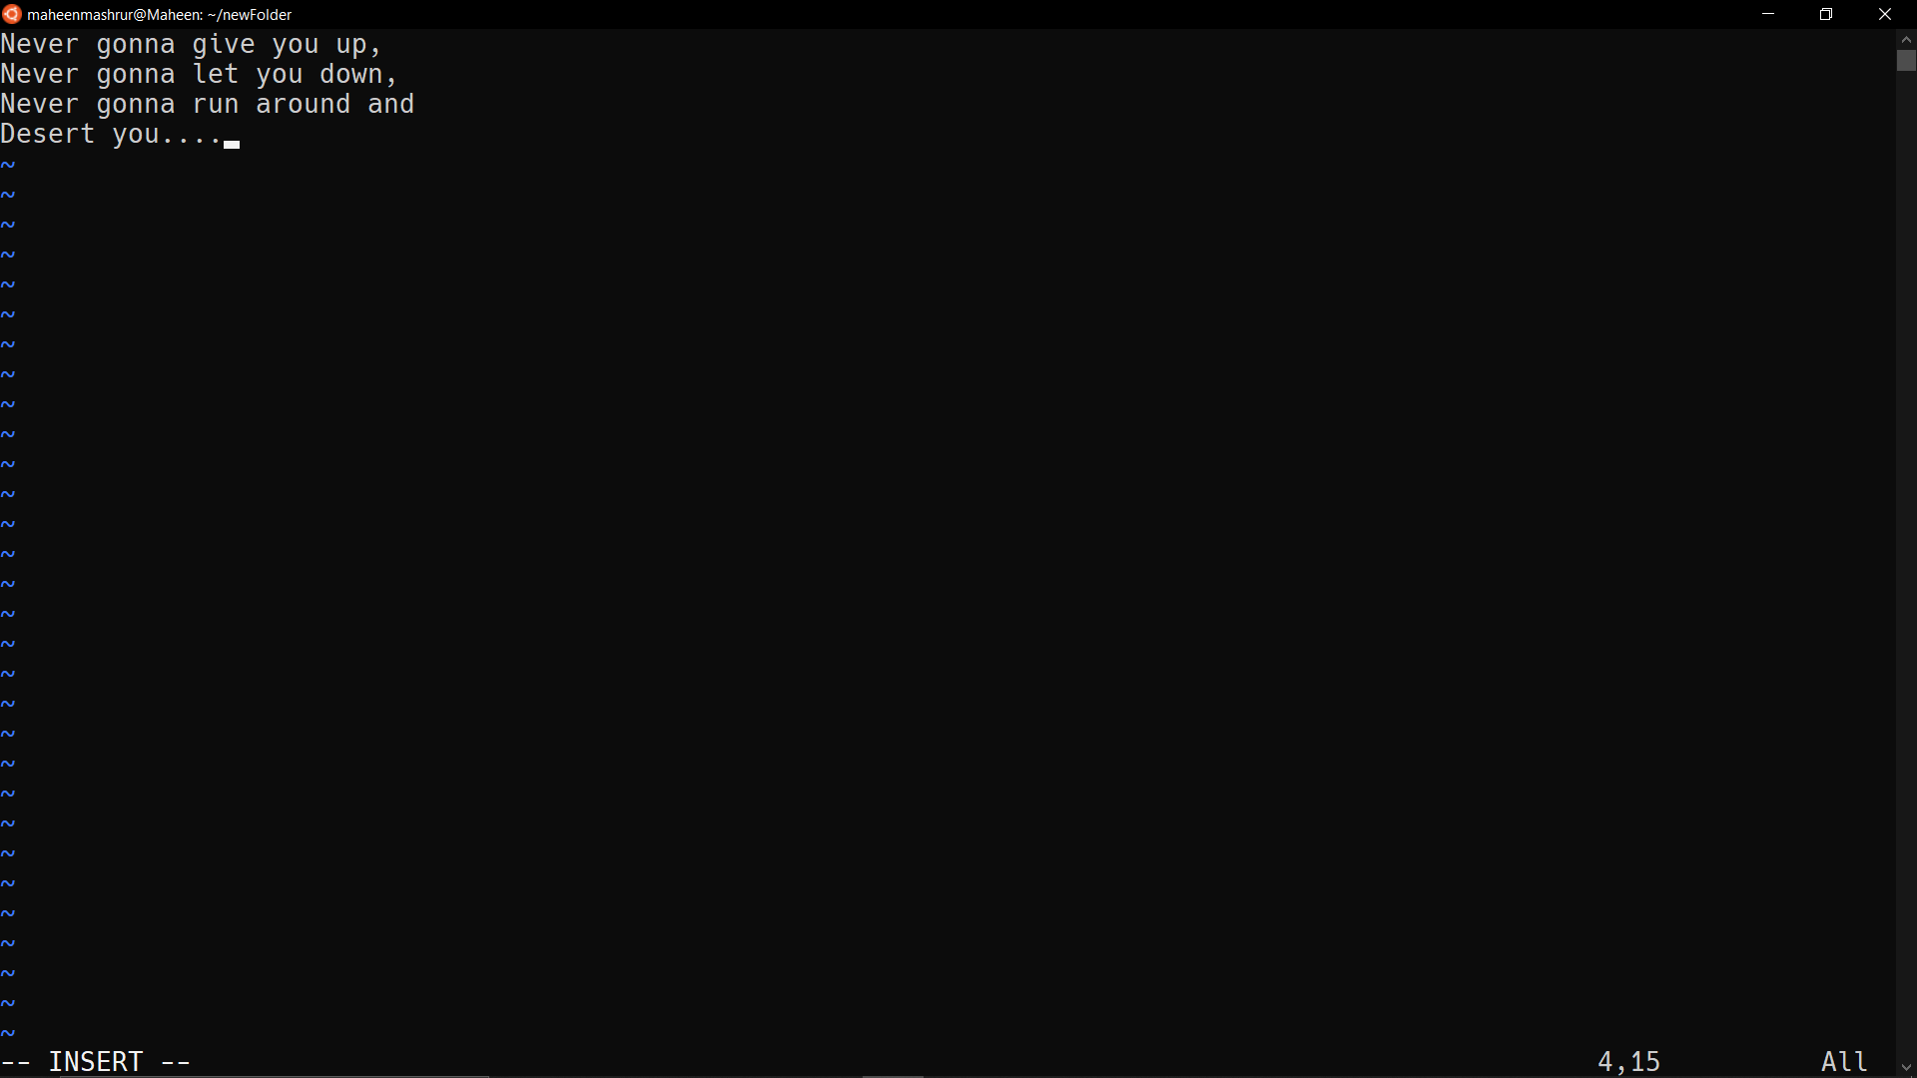
3. df command (with –m flag)  
   “df” command shows the disk space (in KB) used by all the partitions of the file system. The “-m” flag shows the size in MB.  
   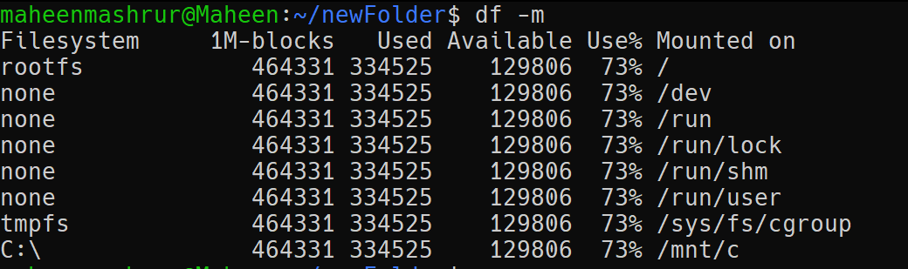
4. du command  
   “du” command shows the disk usage of a directory (in KB).  
   
5. tar command (with –cvf, -tvf and –xvf flag)  
   “tar” command is used with it’s various flags to work with a type of archive called Tarball. The “-cvf” flag is used to create a tarball, “-tvf” is used to list the contents of a tarball and “-xvf” is used to decompress a tarball archive.  
   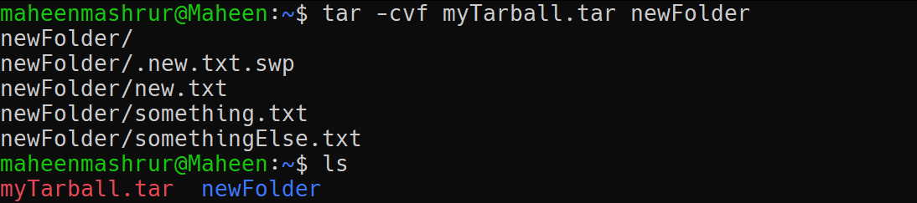  
   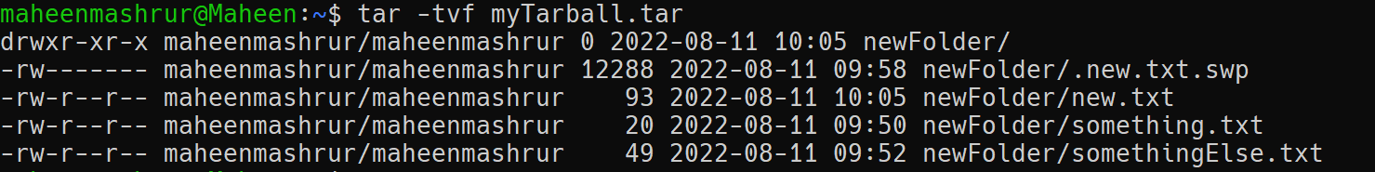  
   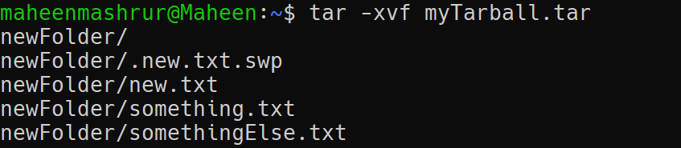
6. “zip” and “unzip” command  
   “zip” command compresses a directory into a .zip archive. “unzip” command decompresses a .zip archive.  
   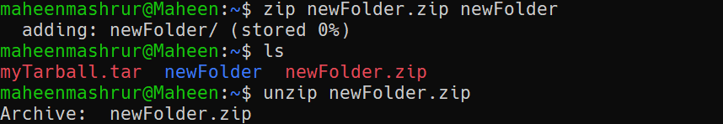
7. uname command (with –a flag)  
   “uname” command shows the operating system name. The “-a” flag shows the operating system details.  
   
8. hostname command  
   “hostname” command shows the host name of the current user. The “-i” flag will show the IP address of the system in the network.  
     
   
9. ping command  
   “ping” command is used to ping a specific URL or IP address. We can stop pinging by control + c.  
   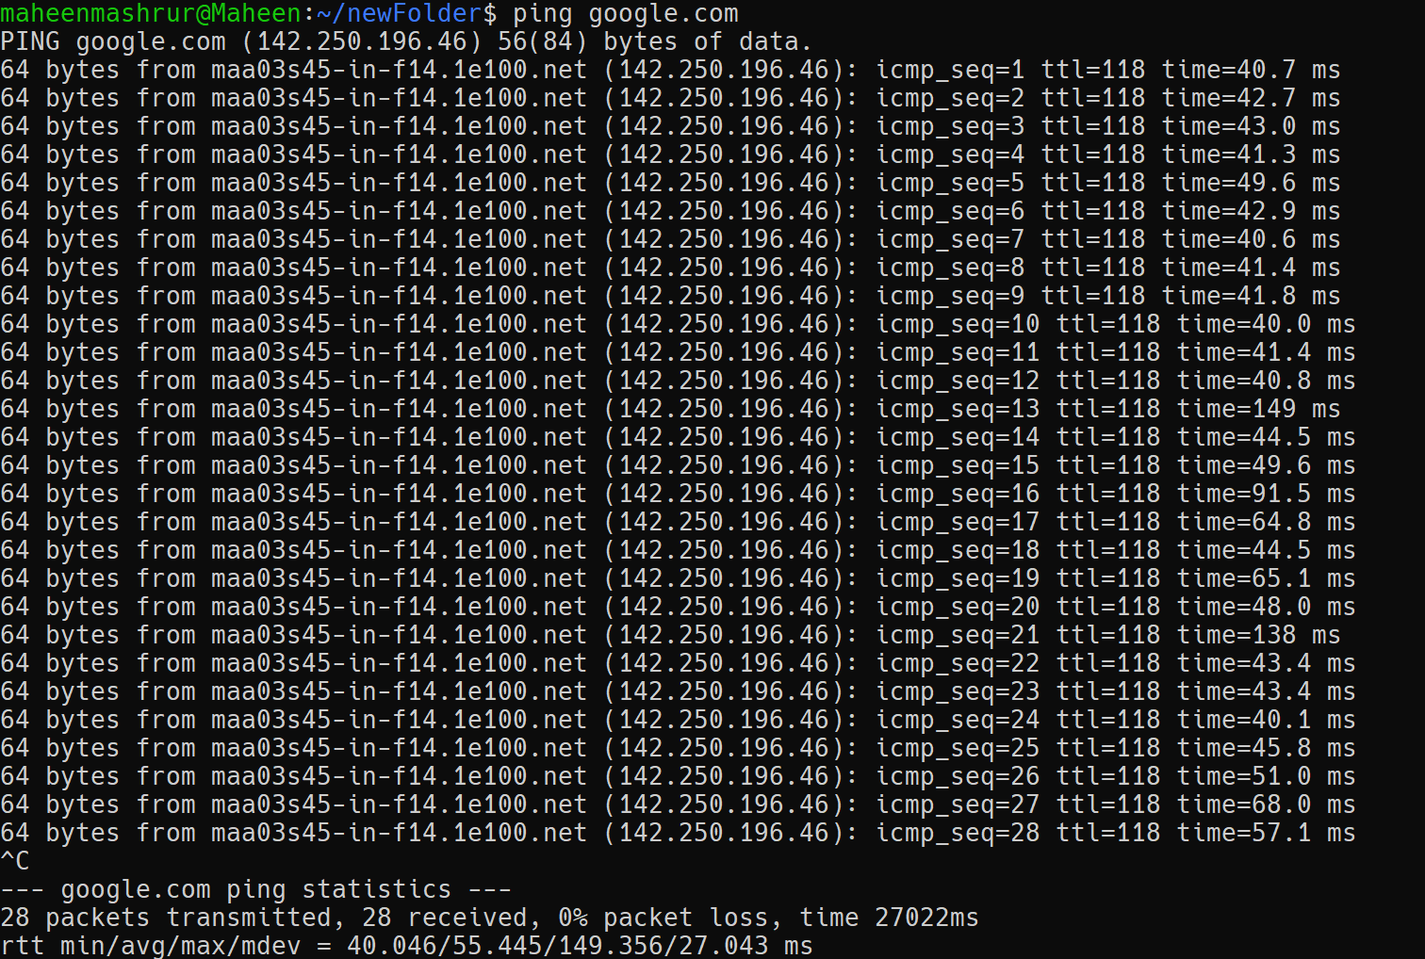
10. chmod command  
    “chmod” command changes the editing access of any file or directory. The flags specify what kind of access we are altering (“-rw” means revoking read-write access).  
    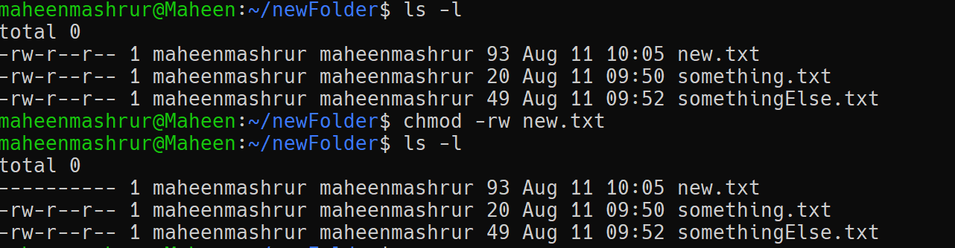
11. locate command  
    “locate” command locates a file in the file system. It may present multiple files if the given query name is matched with multiple files.  
      
    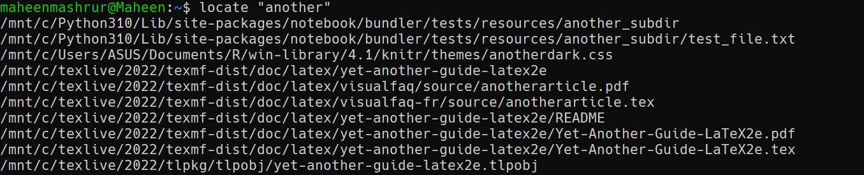
12. “sudo” and “apt-get” command  
    “apt-get” is used to install packages. It is used with “sudo” command which grants administrative privilege.  
    